Risk Group Selector

# Objective

To identify groups with contrasting risk profiles using GM and other key predictors to optimize Underwriting strategy

# Proposed Method

Decision Tree algorithm is used to as a supervised approach to define the groups with maximum separation in terms of Risk Profile (i.e. Delinquency Target Variable)

# Key Parameters:

**Base:** Existing Clients with DECISION_WF_FINAL IN ('g_CE','d_PRE','e_POST','c_PRELIM2')

**Target Variable:** FSTPD30

**Train Set:** Jul’20

**Test Set:** Aug’20 Onwards

**Predictors Considered:** POS_MAR20_GM_EXI, POS_GSPN_V2, PRODUCT_GOODS_TYPE, PRODUCT_CREDIT_TYPE, AMT_CREDIT, DP_PCT, CLIENT_EMI, POS_TYPE, SCORE_CB

# Scripts

 

# Result

Overall Approval Rate increase by 2% over current Strategy

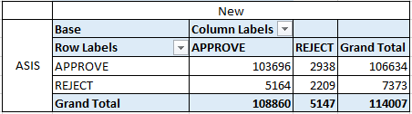

Overall Delinquency Rate(FSTPD30) reduce by 0.5% over current strategy

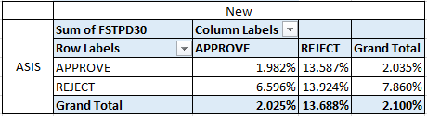

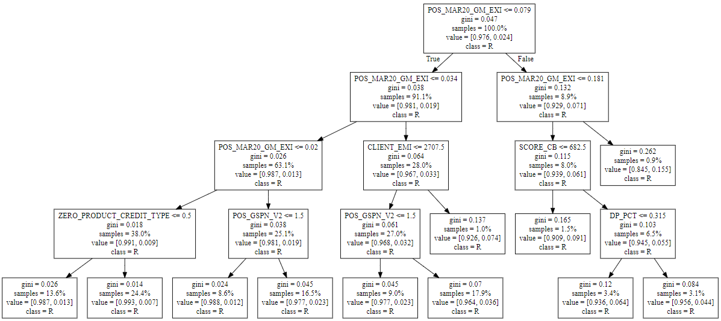

# Recommendations

* The analysis suggests that split on GM is able to identify the worst clients. We can simplify the RGS to be based just on GM currently
* The remaining predictors create differentiation but in mid deciles, hence not useful in decision making. These segments to be kept for monitoring purpose
* Rerun the decision tree when we have new data source like Airtel etc.